**Lab 01 – Part 2**

Name: **Sungsoo Cho** ID: **121182190**

**Explore the Database**

In the object browser, expand **Tables.**

1. How many tables have been created? List the name of created tables.

8 tables have been created. Their names are customers, employees, offices, orderdetails, orders, payments, productlines, products.

1. Right click on table **customers**. Select the first option **Select Rows – Limit 1000**.

How many rows are selected from table **customers**?

122 rows

1. What SQL statement is executed in the SQL tab after selecting **Select Rows – Limit 1000**. Write the statement in the space provided below.

SELECT * FROM classic_models.customers;

You will learn how to select rows and columns from a table by writing SQL select statements later in this course.

1. How many columns does the **customers** table have? List the column names.

There are 13 columns. Their names are customerNumber, customerName, contactLastName, contactFirstName, phone, addressLine1, addressLine2, city, state, postalCode, country, salesRepEmployeeNumber, creditLimit

1. What is the value of each column in the first row in table **customers**? Write the column name and the column value.

customerNumber: 103, customerName: Atelier graphique, contactLastName: Schmitt, contactFirstName: Carine, phone: 40.32.2555, addressLine1: 54, rue Royale, addressLine2: NULL, city: Nantes, state: NULL, postalCode: 44000, country: France, salesRepEmployeeNumber: 1370, creditLimit: 21000.00

1. Write the number of rows and columns for the rest of the tables in your schema.

Table Name Rows Columns

employees 23 8

offices 7 9

orderdetails 2996 5

orders 326 7

payments 273 4

productlines 7 4

products 110 9

1. Right click on table **employees**. Select **Alter Table**. In the column subtab, you can see the list of columns and edit them. Do not modify any column.

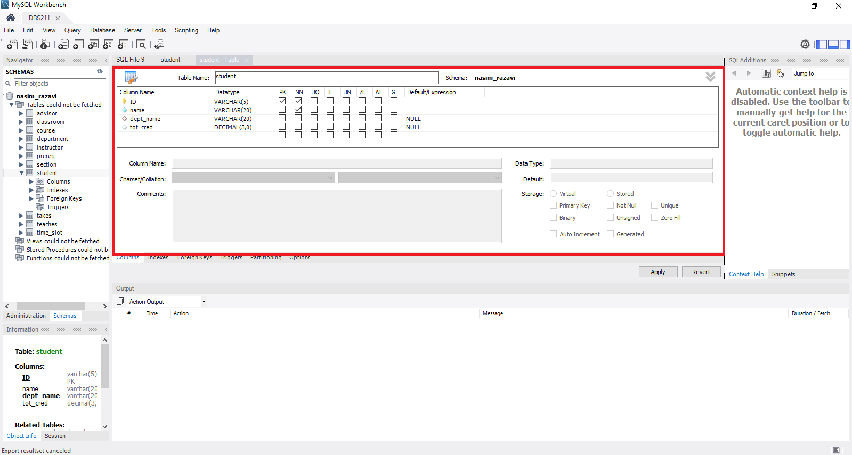

List the column names and types for table **employees**.

Column Name Column Type

|  |  |
| --- | --- |
| employeeNumber | int(11) |
| lastName | varchar(50) |
| firstName | varchar(50) |
| extension | varchar(10) |
| email | varchar(100) |
| officeCode | varchar(10) |
| reportsTo | int(11) |
| jobTitle | varchar(50) |

1. Open a new SQL tab.

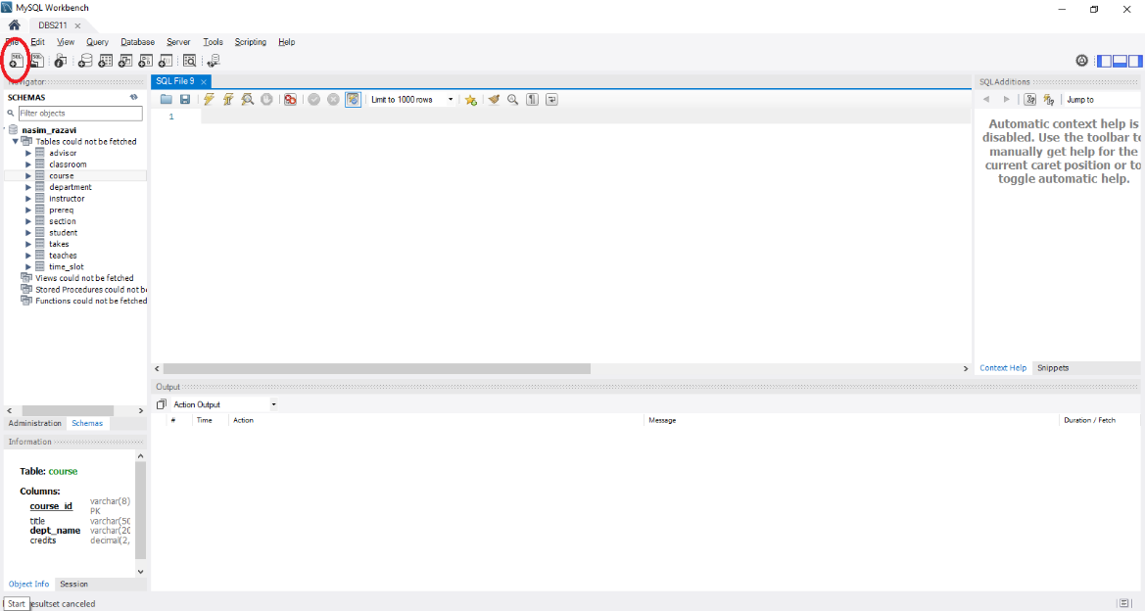

Write the following SQL statement in the new tab.

desc offices;

You can also write

describe offices;

Select the run button to execute the statement. See the next image for the execution button.

What is the result of the statement execution?

|  |  |  |  |  |  |
| --- | --- | --- | --- | --- | --- |
| officeCode | varchar(10) | NO | PRI |  |  |
| city | varchar(50) | NO |  |  |  |
| phone | varchar(50) | NO |  |  |  |
| addressLine1 | varchar(50) | NO |  |  |  |
| addressLine2 | varchar(50) | YES |  |  |  |
| state | varchar(50) | YES |  |  |  |
| country | varchar(50) | NO |  |  |  |
| postalCode | varchar(15) | NO |  |  |  |
| territory | varchar(10) | NO |  |  |  |

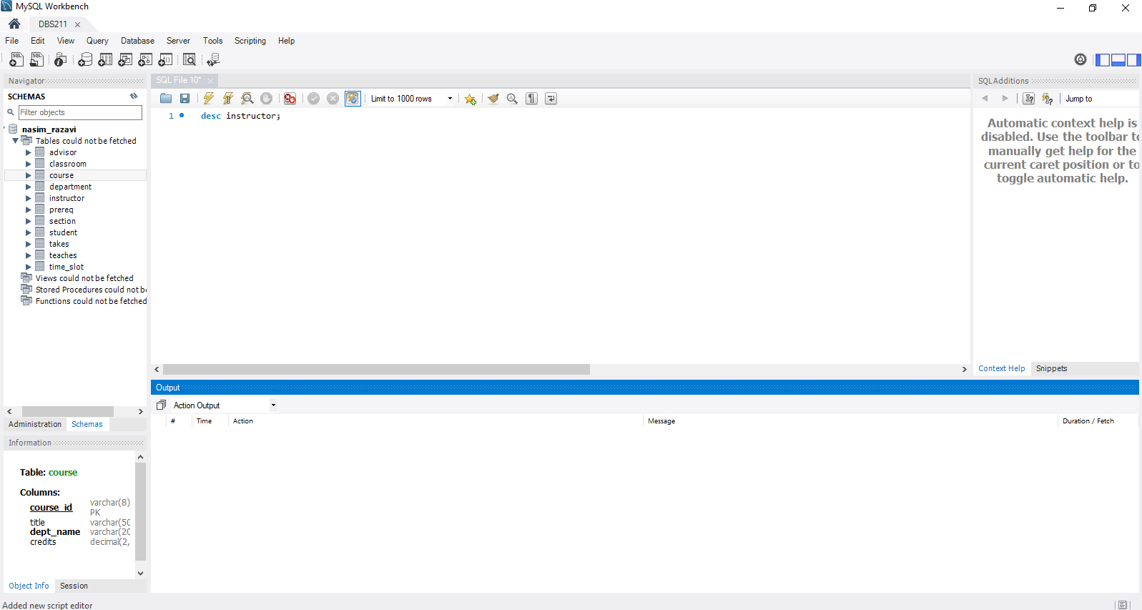

The image of the result:

